**Practical Assignment**

**Basic Linux Command & File Management**

***Sujal chuwan***

***12220076@gcit***

* **Basic Linux Commands**

Display the directory path that you are currently in.

List all the directories in your current working directory with their permissions.

Change your shell’s current working directory to the first listed directory in the previous question. Use the appropriate command without argument to change your current working directory to ***home***.

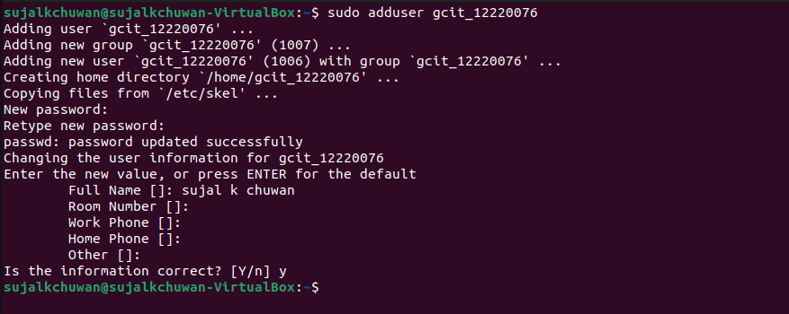

* **Files and Directories**

Create files and directories as per the given structure.

Create three directories using a single command line, namely documents, pictures, and audio in your home directory. **[.odt files must have information about yourself as content]**

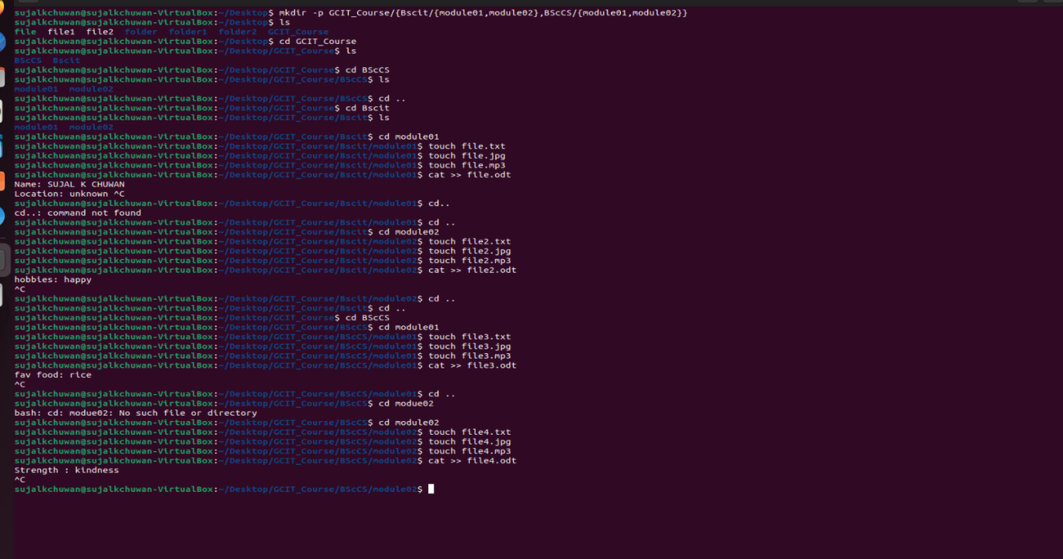

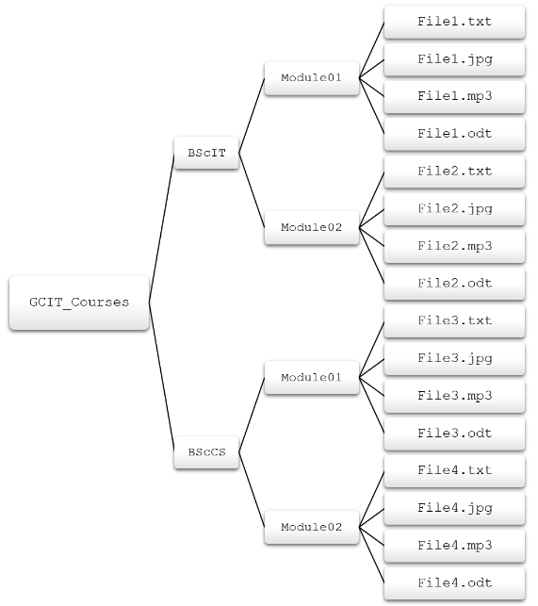

Move the .txt files to the document directory, the image filecd..s to the pictures directory, and the audio files to the audio directory. ***[Hint: Continue in your current directory]***

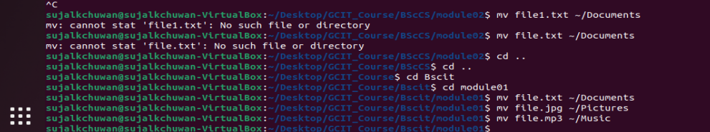

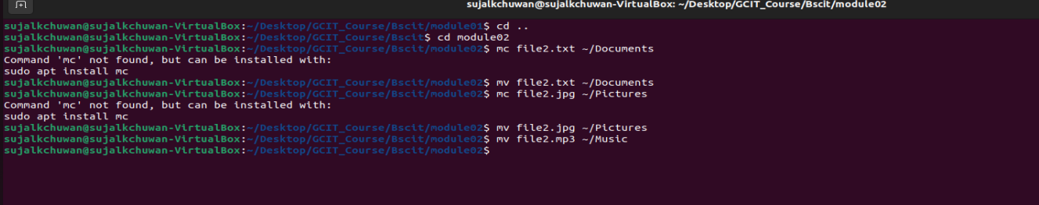

Copy the .odt files to the document directory. Then remove the entire source directories

containing the original copy of .odt files in the BScIT directory.

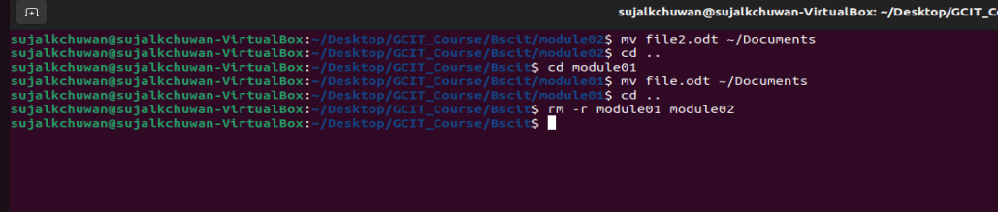

From the BScCS directory, remove all the .odt files without removing their immediate directory.

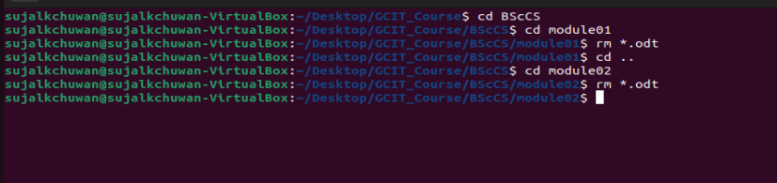

Remove the entire “GCIT Course Structure” directory.

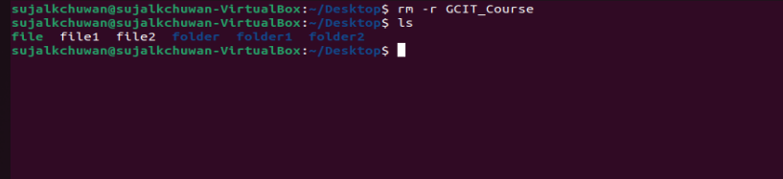

* **Files and Permissions**

Create a new group ***workshop*** with a GID of 2022.

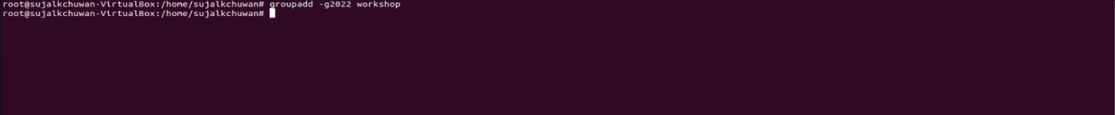

Create the trainer1, trainer2, and trainer3 users with a workshop as their supplementary cleargroup. Use “traniner_22” as the default password for all the users.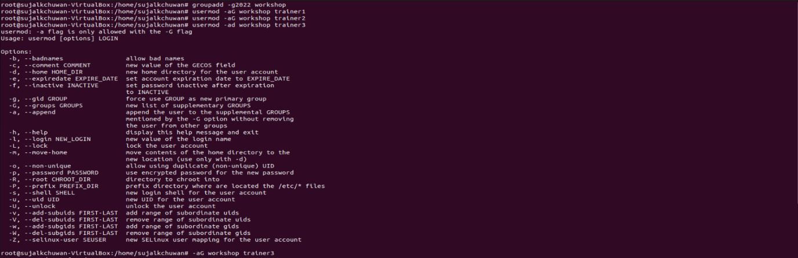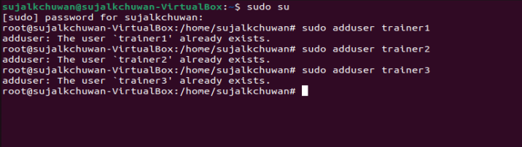

Create a directory called “Training Materials” in your present working directory. 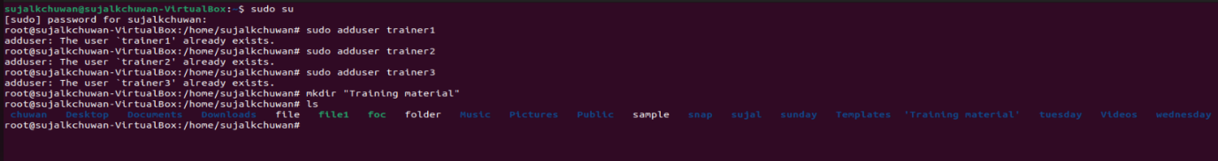

Change the group ownership of the “Training Materials” directory to the workshop group.

Ls

sut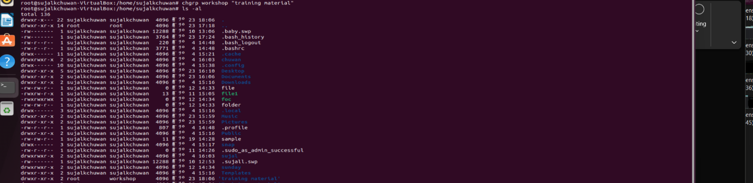

Check whether users in the workshop group can create and edit files in the “Training Materials” directory.

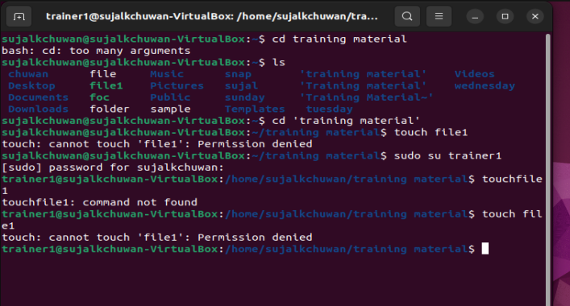

Set permissions on the “Training Materials” directory. On the “Training Materials” directory, configure read, write, and execute permissions for the owner and group, and no permissions for other users. Verify that the permissions are correctly set.

Clear

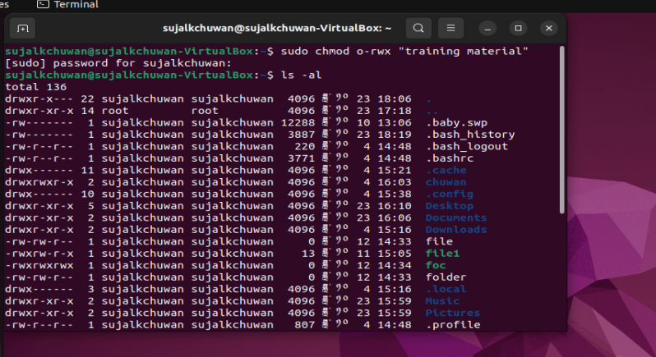

Confirm that users in the workshop group can now create and edit files in the “Training Materials” directory. Users not in the workshop group cannot edit or create files in the “Training Materials” directory.

